Software Requirements Specification

Cancer Central Clinical Participant Registry (C3PR)
Version 2
Duke Comprehensive Cancer Center

Background/Summary
This document describes the use cases for the C3PR V2 software. These communicate to developers and end users the requirements of the system at a functional level. Each use case provides one or more scenarios that convey how the system should interact with the users called actors to achieve a specific business goal or function

Table of Contents

1 Introduction 5
1.1 Overview 5
1.2 Related Documents 5
2 Actors and Roles 6
2.1 Actors 6
2.2 Roles 7
3 Manage Subjects and Study Personnel 8
3.1 Create Subject 8
3.2 Create Study Personnel 8
3.3 Update Subject 8
3.4 Update Study Personnel 8
3.5 Verify Subject 8
3.6 Verify Study Personnel 8
3.7 Delete Subject 8
3.8 Delete Study Personnel 8
3.9 Manage Subject Address 8
3.10 Manage Subject Contact 9
3.11 Manage Study Personnel Contact 9
3.12 Search for a Subject 9
3.13 Search for a Study Personnel 9
3.14 View a Subject 9
3.15 View a Study Personnel 9
4 Manage Protocol 10
4.1 High Level Manage Protocol Use Case Diagram 10
4.2 High Level Protocol Data Capture Use Case Diagram 11
4.3 Create Study/Protocol Definition Manually 11
4.4 Load Protocol Definition from a File 14
4.5 Get Protocol/Study Definition via Protocol Message from External Source 16
4.6 Search for Protocols 17
4.7 View Protocol 19
4.8 Update Protocol 20
4.9 Approve Study/Protocol Definition 22
4.10 Amend Study/Protocol Definition 23
4.11 Abstract Protocol Data 24
4.12 Register Patient to a Protocol Arm 24
4.13 Synchronize Creation of Protocol Definition with Study Calendar 25
4.14 Synchronize Registration of a Patient on a Protocol Arm with Study Calendar 26
5 Manage Registration 28
5.1 Register a New Patient to a Study 28
5.2 Register an Existing Unregistered Patient to a Study 28
5.3 Register an Existing Registered Patient to a Study 28
5.4 Register Patient to Local Protocol Study 28
5.5 Register Patient to External Protocol Study 28
5.6 Associate Disease to Patient 28
5.7 View Subject Registration History 28
5.8 Reserve Registration 29
5.9 Store Patient Screening Data 29
5.10 Submit Pending Registration Information 29
5.11 Confirm Submitted Registration Information 29
5.12 Replicate Registration to Companion Protocol 29
5.13 Replicate Registration to Local Site 29
6 Manage Randomization 29
6.1 Email Notify Registrar 29
6.2 Display Notification 29
6.3 Randomize Using Protocol Block 30
6.4 Randomize Using Call-out 30
7 Manage Eligibility Criteria 30
7.1 Approve Eligibility Criteria 30
7.2 Exempt Eligibility Criteria 30
7.3 Import Eligibility Criteria 30
8 Access Clinical Data 30
9 Manage Stratification 30
10 Manage Relationship 31
10.1 Create Relationship 31
11 Login 31
12 Reporting 31
13 From C3PR Release 1 (Not Yet Analyzed) 31
13.1 Maintain Protocol Strata Randomized List 31
13.2 Synchronize Subject with CDW 31
13.3 Assign Protocol Part to Subject 31
13.4 Generate Referral Letter 31
14 Integration 31
15 Overall Requirements 32
15.1 Requirements Prioritization 32
16 Sign Off 33
16.1 Approval 33

Introduction

Overview
Researchers, who conduct clinical trials themselves and often require comparative data for dosing, measurable clinical trial end-points, model validation, encounter difficulty accessing aggregate clinical trials data. This, in turn, limits their ability to advance the science. The development and deployment of a central registry, containing requisite information on clinical trials, will provide all groups (patients and their families indirectly, community physicians and cancer researchers directly) to meet their diverse set of informational and data needs.
C3PR Release 1 provides a highly configurable participant registry for managing clinical study registration at a single site. However, it cannot easily manage cross-site studies, and it can be very difficult to install, configure, and manage. The primary goal of C3PR Release 2 is to build upon Release 1 to make it more generally useful to the cancer research community. A scoping goal will be for C3PR to manage participant registration to multi-site studies. This involves the integration of C3PR instances at different centers. Additionally, integration beyond C3PR will be needed to perform institution-level and PI-level eligibility checks. The current registration model is somewhat limited, allowing for simplistic randomization based upon manual assignment of participants to arms. Furthermore, protocol management in C3PR will be greatly enhanced. Though C3PR is not intended as a central protocol repository, protocol information is critical to the registration process. Protocol information will be expanded to meet the use cases of multiple eligibility check-points, multi-institutional studies, and differing randomization schemes. C3PR Release 1 provided registration from a participant-centric standpoint. This workflow will be enhanced to provide registration from a protocol-centric view, and reporting will be extended to provide this information to external systems to generate complex reports.

Related Documents

- Vision and scope document
https://gforge.nci.nih.gov/plugins/scmcvs/cvsweb.php/c3prv2/documentation/communication/c3prv2_vision_scope.doc?cvsroot=c3prv2
- Communication Plan
https://gforge.nci.nih.gov/plugins/scmcvs/cvsweb.php/c3prv2/documentation/communication/c3prv2_communication_plan.doc?cvsroot=c3prv2
- Use case document
https://gforge.nci.nih.gov/plugins/scmcvs/cvsweb.php/c3prv2/documentation/use_cases/c3prv2_use_cases.doc?cvsroot=c3prv2

- Project plan
https://gforge.nci.nih.gov/plugins/scmcvs/cvsweb.php/c3prv2/documentation/planning/c3prv2_project_plan.doc?cvsroot=c3prv2
- Risk matrix
https://gforge.nci.nih.gov/plugins/scmcvs/cvsweb.php/c3prv2/documentation/risks/?cvsroot=c3prv2

Actors and Roles
The actors are the actual users of the system. They can have one or more roles in the system. These roles can be assigned and revoked based upon specific protocols. Roles will define the privileges that an actor has to perform functions within C3PR.

Actors

Subject Matter Expert
The Subject Matter Expert has an intimate understanding of the patient registration workflow. This will be one of the primary users of the C3PR system, working with C3PR on a regular basis to create protocols, subjects, and register subjects.

System Administrator
The System Administrator has an intimate understanding of how C3PR is internally functions. This will be the primary user that installs and administrates C3PR.

External System
The External System is a piece of software that programmatically interacts with C3PR through one or more of its APIs. This will be a user that populates data in C3PR or receives messages from C3PR.

Roles

Subject
A Subject (patient) can be registered to one or more protocols and has no privileges to perform any functions in C3PR.

Principle Investigator
The Principle Investigator has read access to all assigned protocols and all Subjects registered to those protocols.

Treating Physician
The Treating Physician has read access to all assigned protocols and all Subjects registered to those protocols.

Data Manager
The Data Manager has read access to all assigned protocols and all Subjects registered to those protocols.

Protocol Manager
The Protocol Manager has write access to all assigned protocols, has the ability to create new protocols, and has read access to all Subjects on assigned protocols.

Registrar
The Registrar has read access to all protocols, and he has the ability to create new Subjects and register those Patients to a protocol.

IRB Manager
The IRB Manager has write access to IRB items in all assigned protocols.

Site Manager
The Site Manager has write access to all protocols, the ability to create protocols, create new Subjects, and register Subjects to any protocol.
Note that there are differences in terminology regarding roles among the various institutions and organizations, as well as variations in combinations of roles. This document will not attempt to capture all the variations and situation specific differences, but describes roles to a sufficient level of detail needed for system functionality.

Manage Subjects and Study Personnel

Create Subject
This use case allows the user to create a Subject in C3PR.

Create Study Personnel
This use case allows the user to create a Study Personnel in C3PR.

Update Subject
This use case allows the user to update the Subject’s record.

Update Study Personnel
This use case allows the user to update the Study Personnel’s record.

Verify Subject
This use case allows the user to approve a Subject.

Verify Study Personnel
This use case allows the user to approve a Study Personnel.

Delete Subject
This use case provides the sole mechanism for a user to delete a Subject’s record that was erroneously entered in C3PR

Delete Study Personnel
This use case provides the sole mechanism for a user to delete a Study Personnel’s record that was erroneously entered in C3PR

Manage Subject Address
This use case allows the user to add/update Subject’s address information.

Manage Subject Contact
This use case allows the user to add/update Subject’s contact information.

Manage Study Personnel Contact
This use case allows the user to add/update Study Personnel’s contact information.

Search for a Subject
This use case allows the user to search a Subject depending upon the search criteria (FN, LN, D.O.B, PID#, etc).

Search for a Study Personnel
This use case allows the user to search a Study Personnel depending upon the search criteria (FN, LN, D.O.B, PID#, etc).

View a Subject
This use case allows the user to view Subject’s record.

View a Study Personnel
This use case allows the user to view Study Personnel’s record.

Manage Protocol

High Level Manage Protocol Use Case Diagram
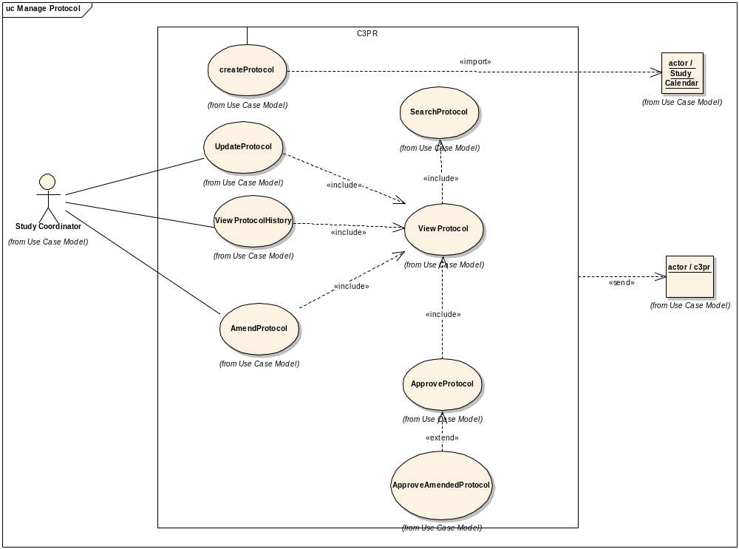

High Level Protocol Data Capture Use Case Diagram
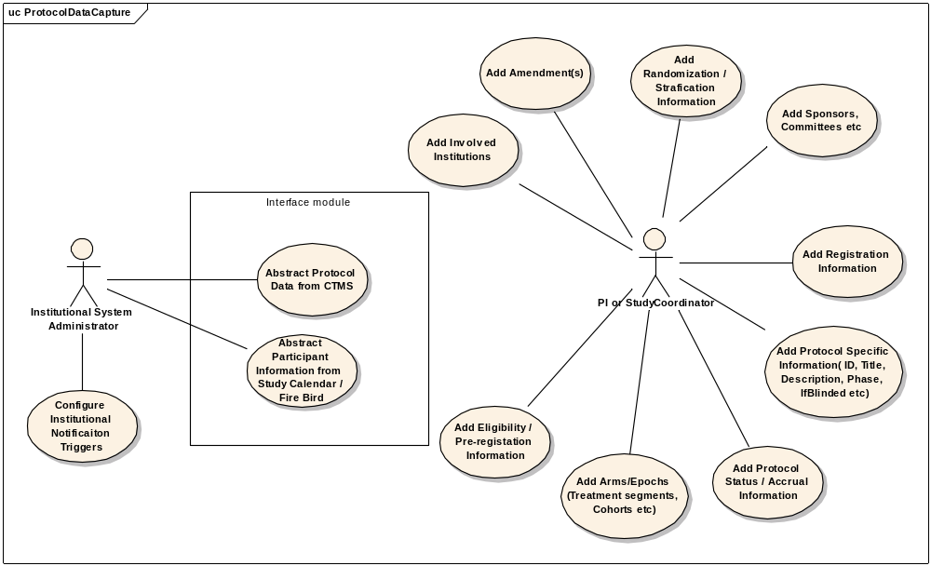

Create Study/Protocol Definition Manually

Use Case Model
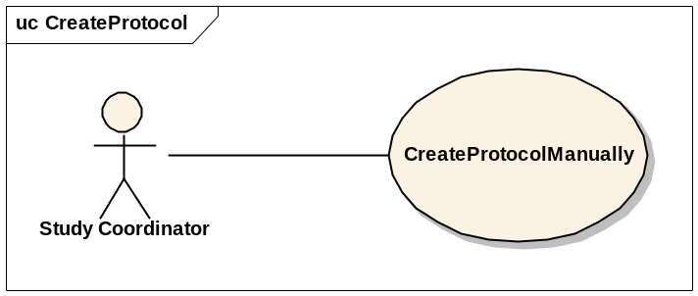

Brief Description
This use-case deals with the manual creation of a protocol by entering each data element of the protocol.

Primary Actor
Study Coordinator or any other designated user of C3PR with role authority to create a Protocol.

Secondary Actors
None

Preconditions
- The user is logged in to the system with a user account that has role authority to create a Protocol.
- The Protocol doesn’t already exist.

Basic Flow of Events
- The user indicates to the system that he/she wants to create a new protocol definition by clicking the Create Protocol link
- The system displays the screen that gives the user option of entering the protocol information manually. The user clicks on the enter protocol manually link.
- The user enters the protocol data elements in the fields.
- The user indicates to the system that the required protocol information has been entered for creation of a new protocol.
- The system displays protocols with matching fields to ensure that the protocol is not a duplicate.

Post conditions
- If the user is logged in to the system with a user account that has role authority to create a Protocol (for example, a Protocol manager), the created protocol is approved.
- If the user was logged in to the system with a role authority to only enter the protocol information, the created protocol awaits for further validation check from a study coordinator/protocol manager before it becomes approved.

Data Items

Data Element | Validation/Notes
(1) Protocol ID | Required
(2) Protocol Amendment | Current
(3) Protocol Amendment Date | Required
(4) Protocol Phase | Required
(5) PI Name | Required (There is only 1 designated PI, the others are AIs)
(6) Branch | Not Required
(7) Protocol Long Title | Required
(8) Protocol Short Title | No/ but would be good
(9) Protocol Description | Required
(10) Precis | Not Required
(11) NCI NCIN Number | Not Required (may not be there)
(12) Registration Tracked | Yes/No (default: Yes)
(13) Multi-Institutional Protocol | Yes/No (default: No)
(14) Involved Institutions
14.1 Name | Required
14.2 Coordinating | Yes/No (default: No)
14.3 Site Investigator | Required (multiple allowed)
14.4. IRB Start Date | Required
14.4. IRB End Date | Required
14.5 IRB approved accrual ceiling | Not Required
14.6 CTEP ID | Not Required
14.7 IRB Name | Not Required
(15) Protocol Accrual Ceiling | Required this ceiling should not be enforcing, or it will cause problems
(16) Protocol Accrual to Date | Default: 0
(17) Sponsor | Organization leading the research (for example, CTEP, NCI, Pfizer)
(18) Sponsor's Protocol ID | Required
(19) Protocol Monitor | For example, CDUS, CTMS, Quintiles
(20) Protocol Monitor's Protocol ID | Not Required
(21) Protocol Type | Not Required
(22) Protocol Design | Not Required
(23) Protocol History | At least 1 required
23.1 Status | Required
23.2 Date of change | Required
(24) Protocol Open Date | For future opening
(25) Protocol Close Date for Accrual | For future closing
(26) Protocol Close Date Final | For future closing
(27) Randomization
27.1 IsRandomized | Required (yes/no) (default: No)
27.2 Method | Method (Required if IsRandomized=Yes) ( a.Book, b. Built-in, c.Call-out)
(28) Arms
28.1 Name | Required
28.2 Description | Required
28.3 Number | Not Required
28.4 Status | Not Required
28.5 Accrual Ceiling | Not Required
28.6 Epoch | Not Required
28.6.1 Name | Not Required
28.6.2 Date | Start/End
28.7 Treatment Segments | Not Required
28.7.1 Name | Not Required
28.7.2 Epoch Name | Not Required
28.7.3 Eligibility at Segment | Not Required
28.8 Eligibility at Arm | Not Required
28.9 Cohort | Required
28.9.1 Yes/No | ??
28.9.2 Name | ??
28.9.3 Expiration Time | ??
(29) Epoch | Not Required
29.1 Name | Not Required
(30) Blinded | Required (yes/no) (default: no)
(31) Blinded Type | Required (If Blinded=Yes)
(32) Eligibility | Not Required
(33) Other Identifiers | Multiple Allowed
33.1 Source | Not Required
33.2 Name | Required
33.3 Value | Required
(34) Pre-Registration
34.1 IfRequired | Yes/No (default: no)
34.2 Eligiblity | Not Required
(35) Disease site
35.1 Name | Not Required

Special Requirements

< First Special Requirement >

Load Protocol Definition from a File

Use Case Model
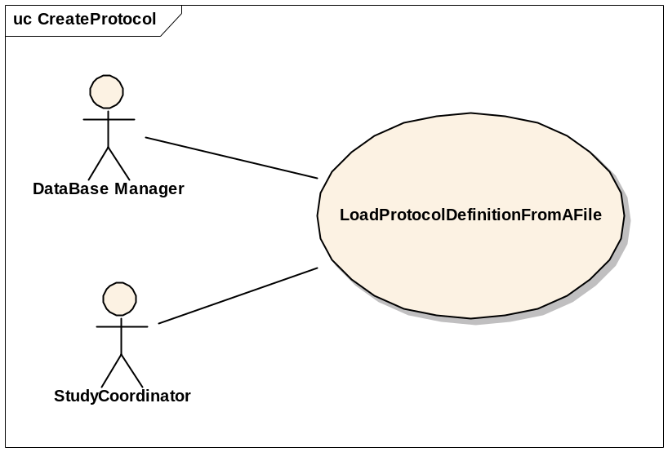

Brief Description
This use-case deals with loading a Protocol from a file that is on the user’s local system.

Primary Actor
Study Administrator or any other designated user of C3PR with role authority to create a Protocol.

Secondary Actors
None

Preconditions
- The user is logged in to the system with a user account that has role authority to create a Protocol.
- The Protocol doesn’t already exist.

Basic Flow of Events
- The user indicates to the system that he/she wants to create a new protocol definition from a file by clicking the Import Protocol link
- The system displays a screen that allows the user to browse their local file system.
- The user selects the appropriate file which contains the information about the protocol to be loaded into the system.
- After selecting the file, the user indicates to the system to create a new protocol definition based on the information in the file.
- The system reads the file and creates a new protocol definition entry.

Postconditions
- If the user is logged in to the system with a user account that has role authority to create a Protocol (for example, a Protocol manager), the created protocol is approved.
- If the user was logged in to the system with a role authority to only enter the protocol information, the created protocol awaits for further validation check from a study coordinator/protocol manager before it becomes approved.

Special Requirements

Get Protocol/Study Definition via Protocol Message from External Source

Use Case Model
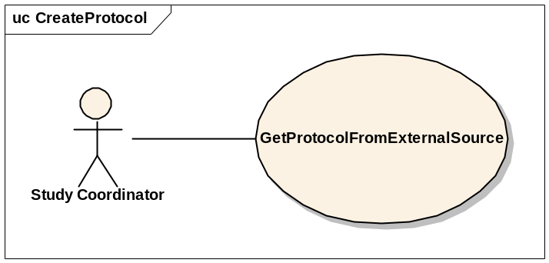

Brief Description
This use-case deals with creation of a Protocol at the local system after getting/importing it from an external source via a Protocol Message.

Primary Actor
Study Administrator, Study Coordinator or any other designated user of C3PR with role authority to create a Protocol.

Secondary Actors
None

Preconditions
- The user is logged in to the system with a user account that has role authority to create a Protocol.
- The Protocol doesn’t already exist.

Basic Flow of Events
- The user indicates to the system that he/she wants to create a new protocol definition by clicking the Import Protocol link
- The system displays a screen that displays the import methods. This screen allows the user to import a new protocol.
- The user clicks on a link, the protocol is imported, and the user views the protocol.
- The user checks the protocol for correctness and updates the protocol entries to correspond to the local site requirements (IRB approval, accrual ceiling, etc).
- After importing the protocol, the user confirms the protocol creation.

Postconditions
The imported protocol waits for further changes/validation with respect to the local site conditions (IRB approval, accrual ceiling, etc) before it is available for use at the local site.

Data Items

Special Requirements

Search for Protocols

Use Case Model
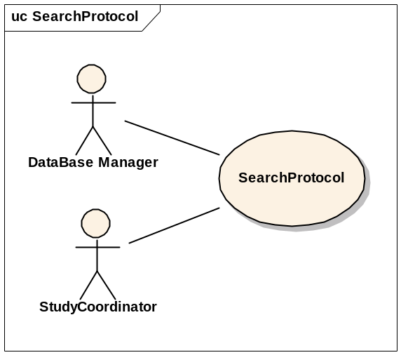

Brief Description
This use-case deals with searching for a protocol. Reasons for searching for a protocol include:
  - Looking for duplicate protocols
  - Begin patient registration
  - Check for eligibility requirements
  - Check protocol status
  - Modify a protocol

Primary Actor
Database Manager, Study Coordinator, Principal Investigator or any other user of C3PR with role authority search for a protocol by specific criteria such as keyword, disease site, phase or PI, or the unique protocol ID..

Secondary Actors
None

Preconditions
The user is logged in to the system with a user account that has role authority to search for a protocol.

Basic Flow of Events
- The user indicates to the system that he/she wants to search for a given protocol definition by clicking the Search Protocol link.
- The user enters the search criteria for the protocol and submits the information to the system.
- The system displays 0, 1 or multiple protocol definitions depending on the search criteria.

Postconditions
The resulting protocol list is in a state that the user can transition to any of the manage protocol or register patient use cases. This means sufficient detail is presented to the user in order to determine which protocol to transition to.

Data Items

Special Requirements

View Protocol

Use Case Model
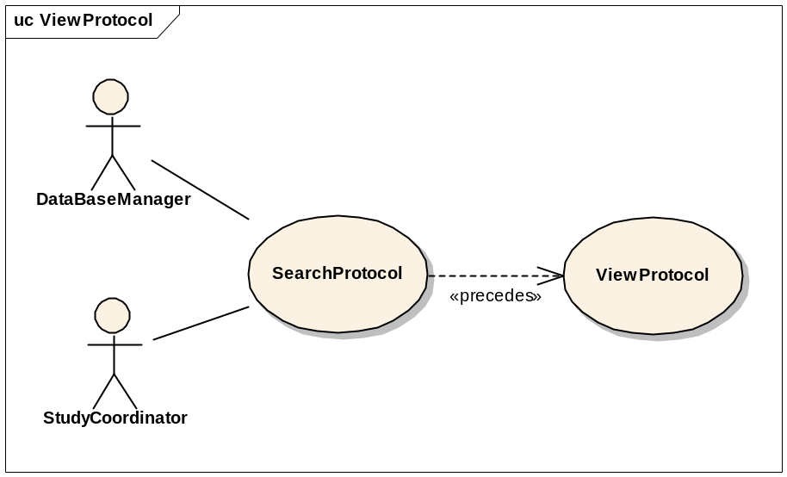

Brief Description
This use-case deals with viewing a protocol.

Primary Actor
Database Manager, Study Coordinator, Principal Investigator or any other user of C3PR with role authority to view a protocol.

Secondary Actors
None

Preconditions
The user is logged in to the system with a user account that has a role authority to view a protocol definition.

Basic Flow of Events
- The user indicates to the system that he/she wants to search for a given protocol definition by clicking the Search Protocol link.
- The user enters the search criteria for the protocol and submits the information to the system.
- The system displays 0, 1 or multiple protocol definitions depending on the search criteria.
- The user selects a protocol and clicks on the link to view that protocol.

Postconditions

Data Items

Special Requirements

Update Protocol

Use Case Model
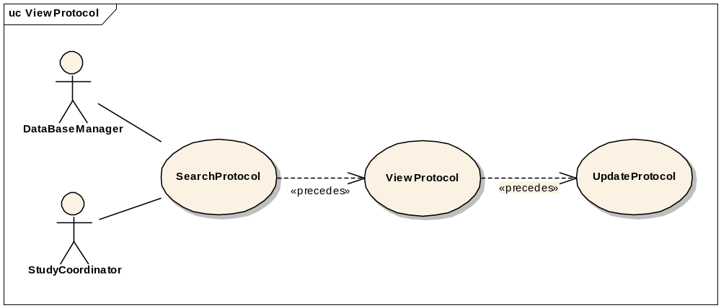

Brief Description
This use-case deals with updating a protocol entry.

Primary Actor
Database Manager, Study Coordinator or any other user of C3PR with role authority to update a protocol definition. This includes changing the status of the protocol (i.e. open versus closed).

Secondary Actors
None

Preconditions
The user is logged in to the system with a user account that has role authority to update a protocol definition.

Basic Flow of Events
- The user indicates to the system that he/she wants to search for a given protocol definition by clicking the Search Protocol link.
- The user enters the search criteria for the protocol and submits the information to the system.
- The system displays 0, 1 or multiple protocol definitions depending on the search criteria.
- The user selects a protocol and clicks on the link to view that protocol.
- The user clicks on the Update Protocol link and updates the necessary fields.
- The user saves the updated protocol information to the system.
- Protocol status and status date fields are updated.

Postconditions
- If the user is logged in to the system with a user account that has role authority to update a protocol, the protocol stands updated
- If the user is logged in to the system with a user account that doesn’t have a role authority to update a protocol, the protocol awaits for further validation check from a protocol manager.

Data Items

Special Requirements

Approve Study/Protocol Definition

Use Case Model
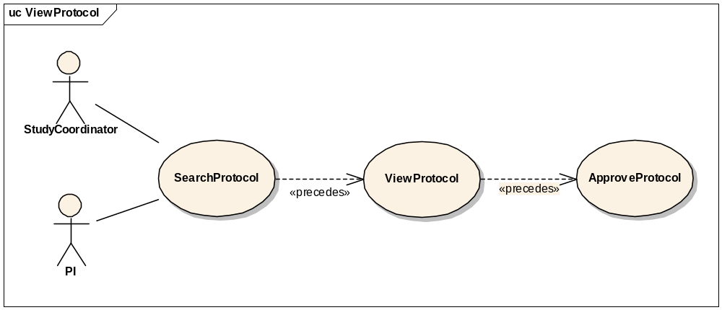

Brief Description
This use-case deals with approval or validation of a protocol definition entry.

Primary Actor
Study Coordinator, PI or any other designated user of C3PR with role authority to approve a Protocol.

Secondary Actors
None

Preconditions
- The user is logged in to the system with a user account that has role authority to approve a Protocol.
- The Protocol definition has already been created but not validated.

Basic Flow of Events
- The user indicates to the system that he/she wants to search for a given protocol definition by clicking the Search Protocol link.
- The user enters the search criteria for the protocol and submits the information to the system.
- The system displays 0, 1 or multiple protocol definitions depending on the search criteria.
- The user indicates to the system that he/she wants to approve a newly created protocol definition by clicking the Approve Protocol link
- The user selects a protocol from a list of newly created protocols.
- The user views the newly created protocol.
- He/She checks for the correctness of the data elements of the protocol against the coordinating site/local site parameters.
- The user approves the newly created protocol by clicking on Approve button or link.

Postconditions

The created protocol has been approved.

Data Items

Special Requirements

Amend Study/Protocol Definition

Use Case Model
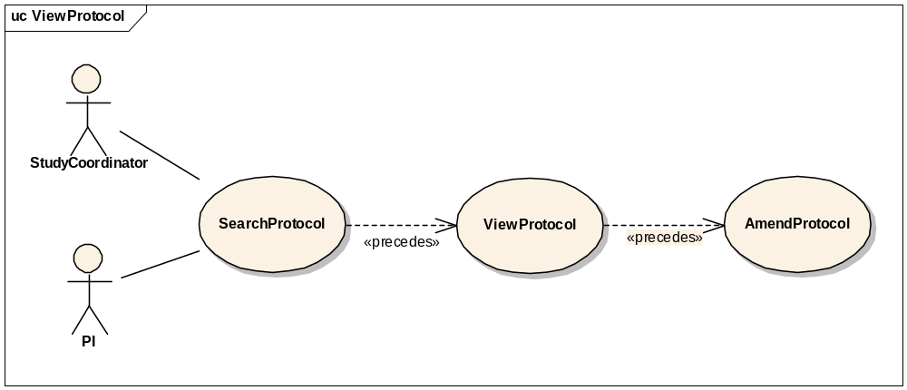

Brief Description
This use-case deals with amending a current protocol definition.

Primary Actor
Study Coordinator, Principal Investigator or any other designated user of C3PR with role authority to amend a protocol definition.

Secondary Actors
None

Preconditions
The user is logged in to the system with a user account that has role authority to amend a protocol definition.

Basic Flow of Events
- The user indicates to the system that he/she wants to search for a given protocol definition by clicking the Search Protocol link.
- The user enters the search criteria for the protocol and submits the information to the system.
- The system displays 0, 1 or multiple protocol definitions depending on the search criteria.
- The user selects the protocol definition for which he/she wants to amend.
- The user indicated to the system that he/she wants to make an amendment by clicking on the Amend Protocol link.
- The user makes the necessary changes to the protocol definition and submits the information to the system by clicking on Amend button or link.

Postconditions
The protocol definition has been amended.

Data Items

Special Requirements

Abstract Protocol Data

Register Patient to a Protocol Arm
This will have a similar flow to edit protocol because a user may want to select a protocol from a search.

Synchronize Creation of Protocol Definition with Study Calendar

Use Case Model

Brief Description
This use case propagates the Protocol definition created in the C3PR system to Study Calendar system via CTMS Hub. The use case assumes that C3PR is the authoritative source for protocol information as far as the PSC is concerned.

Primary Actor
Study Administrator or any other designated user of C3PR with role authority to create a Protocol.

Secondary Actors
- CTMS Hub (caExchange or some other messaging infrastructure)
- Patient Study Calendar (PSC)
- Study Coordinator

Preconditions

Successful Creation of Protocol in C3PR system
The Protocol definition has been successfully created in the C3PR system (refer to use cases 3.1 and 3.2) by a user with a user account that has role authority to create a Protocol.

Basic Flow of Events
- The system generates a message in a predetermined format containing the new protocol information.
- The system then submits the new protocol message to the CTMS Hub.
- The CTMS Hub determines where the message needs to be delivered to, which is Study Calendar system in this case.
- The CTMS Hub transforms the new protocol message into a message format that the Study Calendar system can process.
- The Study Calendar system processes the protocol message and creates the Protocol Definition.
- After successfully processing the new protocol definition message, the Study Calendar system sends an acknowledgment to the CTMS Hub indicating the successful creation of a Protocol Definition in the Study Calendar system.
- The CTMS Hub sends an email notification indicating the creation of a new Protocol Definition to relevant actors including the Study Coordinator.

Postconditions

Creation of Protocol Definition in C3PR and PSC
A Protocol Definition created in the C3PR is replicated in the PSC.

Email Notifications
Email notifications are sent to relevant actors indicating the creation of a new protocol.

Data Items

Special Requirements

Synchronize Registration of a Patient on a Protocol Arm with Study Calendar

Use Case Model

Brief Description
This use case essentially deals with propagating the registration information of a patient on a Protocol Arm created in the C3PR system to Study Calendar system via CTMS Hub.

Primary Actor
Registrar or any other designated user of C3PR with role authority to register a patient on a Protocol Arm.

Secondary Actors
- CTMS Hub
- Patient Study Calendar (PSC)
- Participant Coordinator

Preconditions

Successful Creation of Protocol in the Study Calendar system
  - The Protocol definition has been successfully created in the Study Calendar system either manually thru the Study Calendar web interface or thru a message from the C3PR system (refer to use case 3.5).

Basic Flow of Events
- The system generates a message in a predetermined format containing the new registration information.
- The system then submits the new registration message to the CTMS Hub.
- The CTMS Hub determines where the message needs to be delivered to, which is Study Calendar system in this case.
- The CTMS Hub transforms the new registration message into a message format that the Study Calendar system can process.
- The Study Calendar system processes the new registration message by creating the Patient record, if the Patient does not already exist in the Study Calendar system, and then creates the calendar for the Arm to which the Patient is being registered to.
- After successfully processing the new patient registration message, the Study Calendar system sends an acknowledgment to the CTMS Hub indicating the successful creation of the calendar corresponding to the Arm that the patient is registered on in the Study Calendar system.
- The CTMS Hub sends an email notification indicating the creation of a new calendar for the Arm that the patient is registered on to relevant actors including the Participant Coordinator.

Postconditions

Creation of Patient record in PSC
A new Patient record is created in the Study Calendar system if the Patient does not already exist in it.

Creation of calendar for the Arm for the Patient
The calendar for the Arm that the Patient is registered on is created in the study calendar system.

Email Notification
Email notifications are sent to relevant actors indicating the creation of the Patient (optional) and calendar.

Data Items

Special Requirements

Manage Registration

Register a New Patient to a Study
This use case will allow the user to register a patient not currently in the C3PR system to a protocol. The user will be required to enter patient information before completing the registration.

Register an Existing Unregistered Patient to a Study
This use case will allow the user to register a patient that is currently in the C3PR system but not registered on a protocol. The user will have to identify an existing patient such that patient information is not duplicated.

Register an Existing Registered Patient to a Study
This use case will allow the user to register a patient that is currently in the C3PR system and registered on a protocol. The user will have to identify a protocol that the patient is not already registered to such that registration information is not duplicated.

Register Patient to Local Protocol Study
This use case allows the user to register a patient to a protocol originated at the local site.

Register Patient to External Protocol Study
This use case allows the user to register a patient to a protocol originated at an external site (coordinating site, CALGB, etc).

Associate Disease to Patient
This use case allows the user to associate a disease/disease site to a patient. This is part of the registration process.

View Subject Registration History
This use case allows the user to view the registration history of a Subject.

Reserve Registration
This use case allows the user to reserve a slot/position for a patient on a protocol so that whenever accrual starts, the patient can be registered.

Store Patient Screening Data
This use case allows the user to store screening data of the patient. This use case is primarily required for reporting purposes; however, this data may be reused during the registration.

Submit Pending Registration Information
This use case allows the user to submit a pending registration.

Confirm Submitted Registration Information
This use case provides for a confirmation message to be sent once a pending registration is submitted. This will be a synchronous message (by email?) such that treatment can immediately begin.

Replicate Registration to Companion Protocol
This use case allows the user to replicate the patient registration information to selected companion protocols.

Replicate Registration to Local Site
This use case allows the user to replicate the patient registration information to the local site.

Manage Randomization

Email Notify Registrar
This use case allows the user to notify the randomization registrar for randomization.

Display Notification
This use provides for a notification to be displayed to the randomization registrar on the website after the user logs in.

Randomize Using Protocol Block
This use case allows the user to fetch randomization from a protocol block stored in C3PR.

Randomize Using Call-out
This use case allows the user to fetch randomization arm via a call-out to an external randomization routine (e.g. the Randomization Hub).

Manage Eligibility Criteria

Approve Eligibility Criteria
This use case allows the user to approve eligibility criteria of a patient.

Exempt Eligibility Criteria
This use case allows the user to exempt the eligibility criteria for a patient (for example, “compassionate treatment exemption”).

Import Eligibility Criteria
This use case allows the user to import eligibility criteria from external sources like caDSR.

Access Clinical Data
This use case allows the user to access clinical data from external systems like C3D.

Manage Stratification
TBD

Manage Relationship

Create Relationship
This use case allows the user to associate a Study Personnel or Subject to other Study Personnel(s) or Subject(s).
More use cases TBD.

Login
This use case allows the user to login into C3PR.

Reporting
TBD

From C3PR Release 1 (Not Yet Analyzed)

Maintain Protocol Strata Randomized List

Synchronize Subject with CDW

Assign Protocol Part to Subject

Generate Referral Letter

Integration
These use cases will allow user to integrate with external systems like caMATCH, CDW, Study Calendar etc.

Overall Requirements

Requirements Prioritization

Priority | Use Case Name | Supp Requirement Ref #
1 | Manage Protocol

Sign Off

Approval

Workspace General Contractor Rep Print Name Date
Architecture Workspace Rep Print Name Date
VCDE Workspace Rep Print Name Date
Workspace Working Group Rep Print Name Date
NCICB Rep Print Name Date

